***03/08/24***

**1)**

import java.util.HashSet;

public class HashSetExample{

public static void main(String[] args){

HashSet<String> set=new HashSet<>();

set.add("Apple");

set.add("Banana");

set.add("Cherry");

set.add("Apple");

System.out.println("HashSet: "+set);

System.out.println("Is Apple in the set? "+set.contains("Apple"));

set.remove("Banana");

System.out.println("HashSet after removing Banana: "+set);

set.clear();

System.out.println("HashSet after clearing:"+set);

}

}

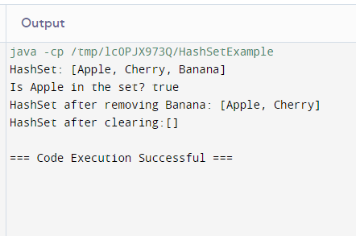

**2)**

import java.util.*;

class GFG {

public static void main(String[] args)

{

Set<String> lh = new LinkedHashSet<String>();

lh.add("BCD");

lh.add("ABC");

lh.add("BAC");

lh.add("ABC");

System.out.println(lh);

lh.remove("Australia");

System.out.println("Set after removing "

+ "ABC" + lh);

System.out.println("Iterating over set:");

Iterator<String> i = lh.iterator();

while (i.hasNext())

System.out.println(i.next());

}

}

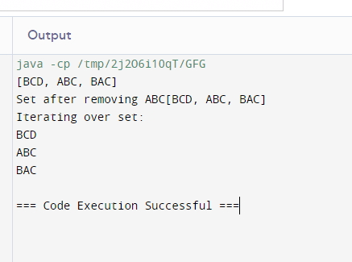

**3)**

import java.util.*;

class GFG {

public static void main(String[] args)

{

Set<String> ts = new TreeSet<String>();

ts.add("jessy");

ts.add("dharu");

ts.add("nandhu");

ts.add("riya");

System.out.println(ts);

ts.remove("dharu");

System.out.println("Set after removing "

+ "dharu:" + ts);

System.out.println("Iterating over set:");

Iterator<String> i = ts.iterator();

while (i.hasNext())

System.out.println(i.next());

}

}

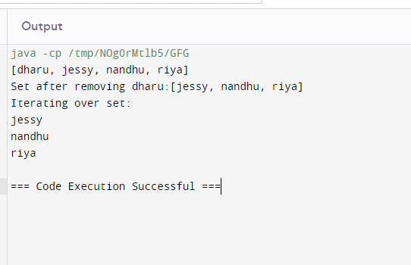

***4)create a list using linked list***

import java.util.LinkedList;

public class Test {

public static void main(String[] args) {

LinkedList<Object> list = new LinkedList<>();

list.add("Know");

list.add(30);

list.add(null);

list.add("Know");

System.out.println(list);

list.set(0, "Program");

System.out.println(list);

list.add(0, "Hello");

list.removeLast();

list.addFirst("Java");

System.out.println(list);

}

}

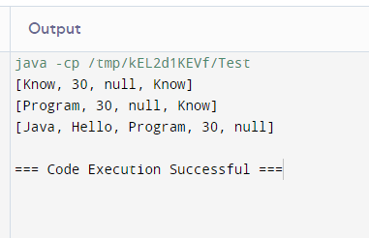

***4)create a list using stack***

import java.util.Stack;

public class Test {

public static void main(String[] args) {

Stack<String> st = new Stack<String>();

st.push("A");

st.push("B");

st.push("C");

System.out.println(st);

System.out.println(st.search("A"));

System.out.println(st.search("Z"));

}

}

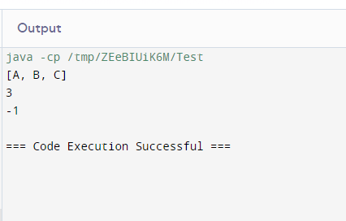

6)create a list using vector method

import java.util.Vector;

public class Test {

public static void main(String[] args) {

Vector<Object> vector = new Vector<>();

System.out.println(vector.capacity()); // 10

for (int i = 1; i <= 10; i++) {

vector.addElement(i);

}

System.out.println(vector.capacity()); // 10

vector.addElement("A");

System.out.println(vector.capacity()); // 20

System.out.println(vector); // [1, 2, 3, 4, 5, 6, 7, 8, 9, 10, A]

}

}

